**Problem 2**

We want to classify the country of an album so we decide to create a LDA model or QDA model.

At first we start by verifying their assumptions, the assumption for LDA are the followings:

1) The data inside group are normal

2) Equal misclassification costs

3) The variance of the groups is the same

While for QDA the third is not necessary.

We perform a Shapiro test on the groups and the resulting p-values are: 0.1296 and 0.9864 so the normality assumption is met.

The equal misclassification cost is the same in this problem but the variance of the groups is not the same as shown from the Bartlett test which return the p-value of 2.2e-16. This means that the hypothesis of equal variance is rejected.

We the decide to use a QDA model assuming a priori probability of 90% in US.

The group means are the following

price average.length

Germany 59.82982 5.891951

US 29.74888 4.377556

And the plot of the classification region is:

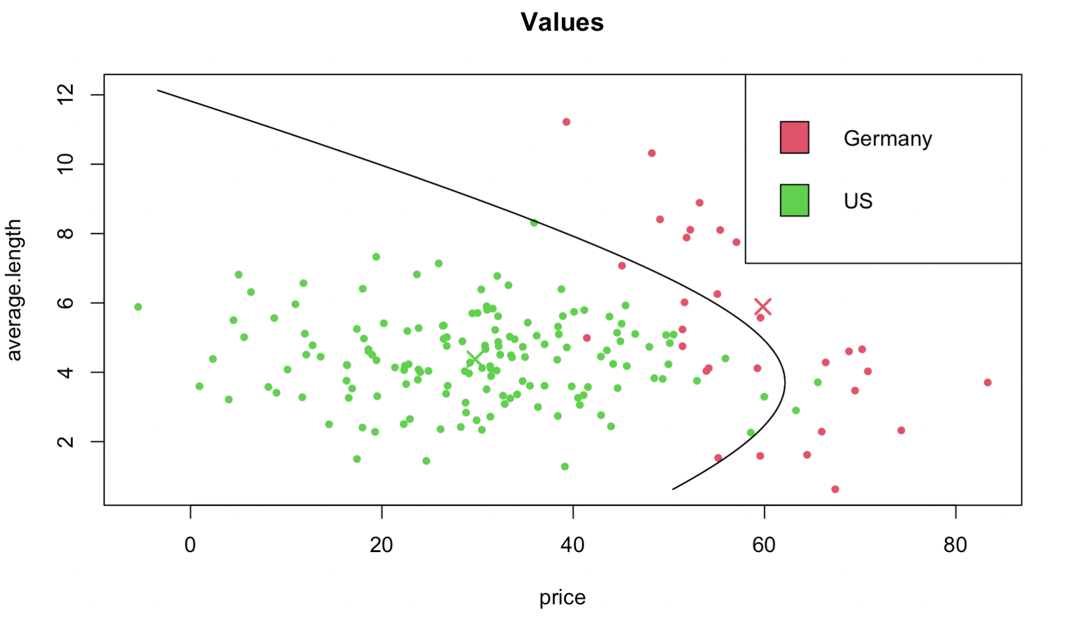

We then compute the AER by leave one out CV and the result is: 0.04868421 which seems good.

If we calculate the posterior probability based on the training set of the classifier are:

Germany US

0.1631317 0.8368683

IF we want to predict the point d the result is: US with this posterior probaility: 0.9231916

Point e: the chosen cost is 10 and the region is the following:

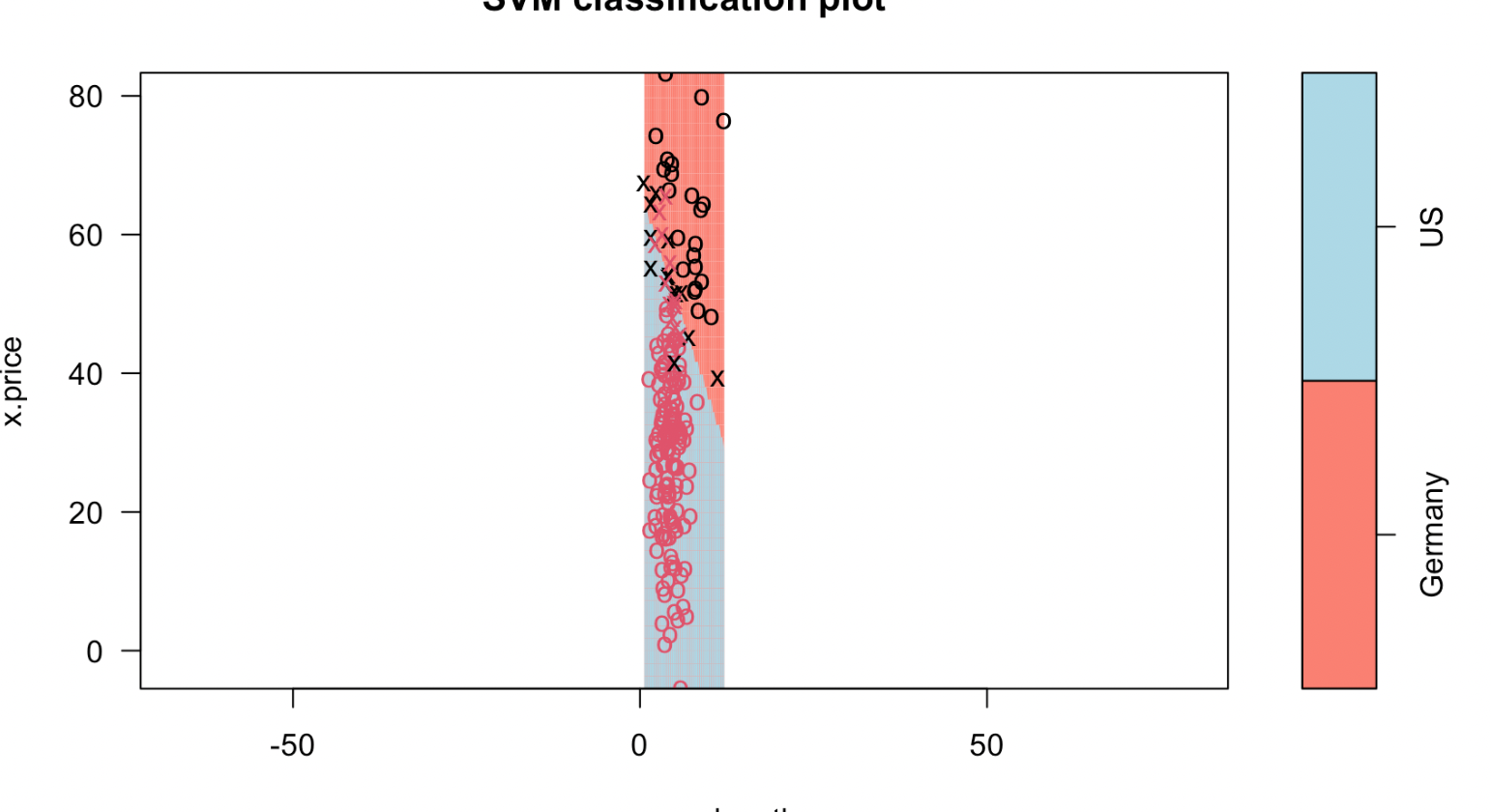

The element at point d is classified as US